

NAME: D DEVISRI PRASAD
REG NO:192425221
COURSE CODE: MLA0214
COURSE NAME: FUNDAMENTAL OF MACHINE LEARNING

QUESTION: Write a program to implement Linear Regression (LR) algorithm in python.
Aim:
To implement Linear Regression to predict numerical values.
Algorithm
- Start the program.
- Define training data.
- Train the Linear Regression model.
- Provide test input.
- Predict the output value.
Code:
from sklearn.linear_model import LinearRegression
X = [[1],[2],[3],[4]]
y = [2,4,6,8]
model = LinearRegression()
model.fit(X,y)
print("Prediction for 5:",model.predict([[5]]))
Output:
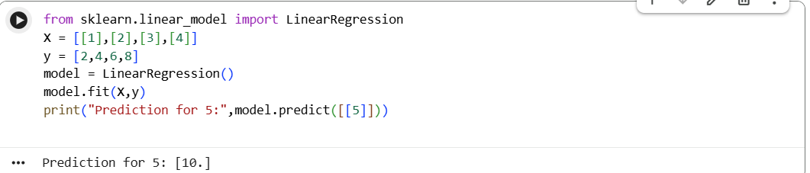
Result
The Linear Regression model successfully predicts the output value for the given input.

